Acoustic Drone Warning Kit
Engineering Guide to Firmware Version 7
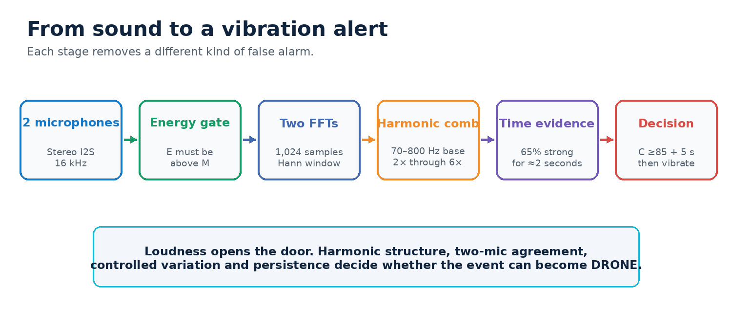
Figure 1. The detector uses independent spectral and time-based checks before issuing an alert.
ONE-SENTENCE LOGIC A sound becomes DRONE only when it is loud enough, has a repeated rotor-like harmonic family, appears on both microphones, varies in a controlled way, and remains consistent for several seconds.

Document purpose
This guide explains what the code measures, why each measurement exists, how the measurements become confidence, and which values should be inspected during field tests. It describes the current normal detector only. The earlier test-tone mode has been removed.
Firmware | Audio analysis | Final alert rule
Version 7 | 16 kHz stereo, 1,024-point FFT, 70–800 Hz base search, harmonics through 6 kHz | Candidate ≥5 s, rolling evidence passes, C ≥85 held ≈2 s

1. Fixed hardware and signal boundary
Two INMP441 microphones share one I2S clock and data bus. Their L/R pins assign separate stereo slots. The ESP32 processes both channels independently, displays the result on a 128×64 SSD1306 OLED, and drives the vibration motor through a PN2222 transistor.
Function | Connection | Engineering reason
Mic 1 channel | L/R → GND | Assigns one I2S slot
Mic 2 channel | L/R → 3V3 | Assigns the other I2S slot
I2S WS / SCK / SD | GPIO 25 / 26 / 33 | Fixed shared digital-audio bus
OLED SDA / SCL | GPIO 21 / 22 | Fixed I2C display connection
Motor control | GPIO 27 through PN2222 | Keeps motor current away from the GPIO
Power | USB power bank | OLED shows USB, not a fabricated battery percentage

CRITICAL CHECK If left and right software channels contain the same data, direction and microphone-agreement scores are invalid. Tap each microphone separately once and set SWAP_MIC_CHANNELS if the displayed sides are reversed.

What the device can claim
- It is a passive acoustic warning prototype.
- Direction is a rough LEFT, CENTER or RIGHT energy bias, not a bearing.
- It does not identify a drone model or calculate distance.
- Fans, motors, tools and compressed media can share parts of a drone spectrum, so real field validation remains necessary.

2. Audio capture, energy and calibration

Audio frames
Parameter | Code value | Meaning
Sample rate | 16,000 samples/s | Nyquist limit is 8 kHz
FFT size | 1,024 samples | 64 ms analysis window
Hop size | 512 samples | 50% overlap, new result about every 32 ms
Window | Hann | Reduces leakage between FFT bins
Frequency resolution | 15.625 Hz/bin | Approximate spacing between reported FFT frequencies

The code maintains a rolling FFT buffer for each microphone. It computes both spectra and keeps the stronger magnitude from either microphone at each frequency bin. This avoids losing a real tone when the two microphones receive it with different phase.

E and M
E is the current combined microphone energy. M is the minimum energy required to consider an event. During the first five seconds, the device measures the background mean and variation, then sets M above that background. M never falls below 1500.
Condition | Background behavior
CLEAR with no candidate | M can adapt slowly upward and faster downward
E ≥ M | Background learning pauses
CHECKING, POSSIBLE or DRONE | Background learning remains frozen
No signal after a noisy startup | Fast downward adaptation helps M recover

WHY THIS MATTERS Loudness is only an entry condition. It cannot create more than 15 confidence points by itself, and E below M forces the current feature total to zero.

3. Finding the rotor-like harmonic family
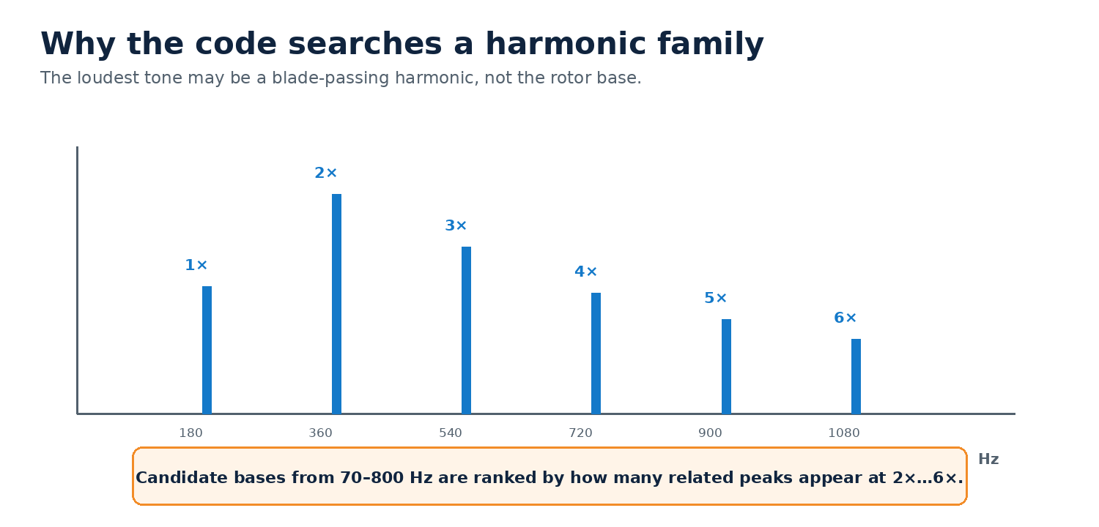
Figure 2. Example harmonic family. Actual frequencies move with rotor speed, propeller geometry and load.
Drone recordings and published quadcopter studies show shaft-rate and blade-passing tones with repeated harmonics. A drone therefore has no single universal frequency. Version 7 searches candidate base frequencies from 70 to 800 Hz and examines related peaks at 2× through 6×, up to 6 kHz.

Harmonic-comb selection
- Reject candidate bases whose peak is not at least four times the estimated spectral noise floor.
- For each remaining base, look around every expected multiple using ±4% tolerance, with at least two FFT bins of tolerance.
- Count a harmonic only when it is strong relative to both the candidate base and the spectral noise floor.
- Rank the candidate by base signal-to-noise plus the number and strength of matching harmonics.
- Use the best-ranked family as f0, even when another individual peak is louder.
Parameter | Value | Purpose
Base search | 70–800 Hz | Covers a broad shaft/BPF starting region
Analysis ceiling | 6,000 Hz | Includes upper tonal structure while remaining below Nyquist
Harmonics | 2×…6× | Tests repeated frequency spacing
Required harmonics | At least 3 | Rejects isolated tones
HarmonicFit | Found ÷ possible | Serial diagnostic showing family completeness

4. Spectrum shape and controlled variation

Structured spectrum
The code measures how much spectral power lies outside the three FFT bins around f0. A pure sine concentrates nearly everything in one narrow region. Flat random noise spreads nearly everything everywhere. Drone-like sound is expected to sit between those extremes because it combines tones, harmonics and broadband propeller noise.
outsideRatio behavior | Interpretation | Score effect
Below 0.30 | Too close to a clean single tone | Low or zero distribution score
Approximately 0.30–0.55 | Increasing useful spectral structure | Rising distribution score
Structured middle region | Harmonics plus broader energy | Up to 15 points
At or above 0.97 | Nearly shapeless broadband noise | Distribution limited to 4 points

RPM-like modulation
Real rotors do not remain at a mathematically perfect frequency. Their control system continuously changes speed with load and flight corrections. The code tracks the moving mean and variance of f0 and energy. It rewards small, controlled movement and penalizes both a frozen test tone and wild frequency hopping typical of music.
Frequency standard deviation | Interpretation
≤0.8 Hz | Too static; little frequency-modulation credit
2.5–45 Hz | Useful controlled movement; full frequency credit
45–80 Hz | Credit tapers as movement becomes excessive
≥80 Hz | Too unstable; no frequency-modulation credit

IMPORTANT A phone or YouTube recording is filtered by the source file, compression, phone speaker and room. It is useful for software checks, but it cannot reproduce the acoustic field of a real outdoor drone.

5. Confidence and the hard evidence gate
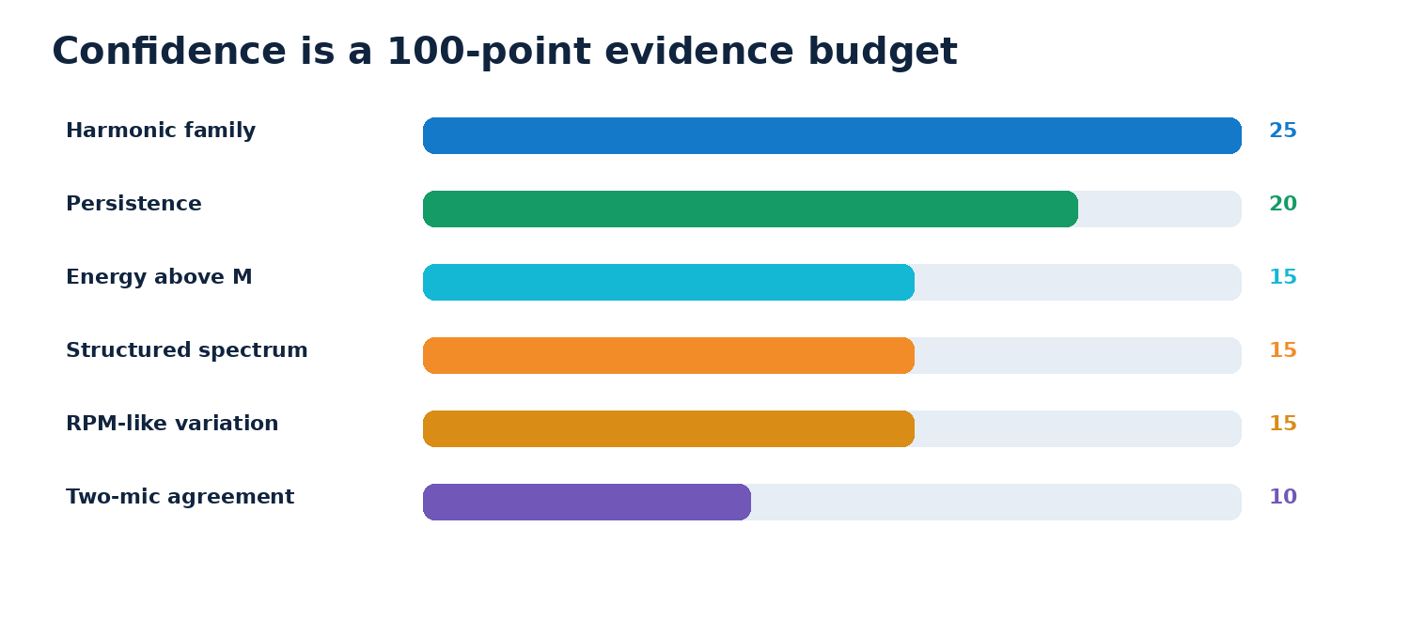
Figure 3. Confidence combines six features. Loudness cannot dominate the result.
Feature | Maximum | What earns points
Energy above M | 15 | E rises clearly above the adaptive threshold
Harmonic family | 25 | Multiple related peaks match f0 multiples
Structured spectrum | 15 | Neither a pure tone nor flat random noise
Controlled variation | 15 | Realistic f0 and amplitude movement
Persistence | 20 | Strong evidence accumulates over time
Two-mic agreement | 10 | Both channels receive a meaningful event

A strong window must pass everything below
Gate | Current requirement
Energy | E ≥ M
Base | Valid f0 found
Harmonics | At least 3
Microphones | Mic agreement score ≥5/10
Warm-up | At least 16 modulation samples
Distribution | Score ≥8/15
Modulation | Score ≥5/15

A strong window adds two persistence units. A failed window subtracts one. This allows brief propeller or playback variation without letting random bursts build confidence indefinitely.

6. Rolling evidence and state machine
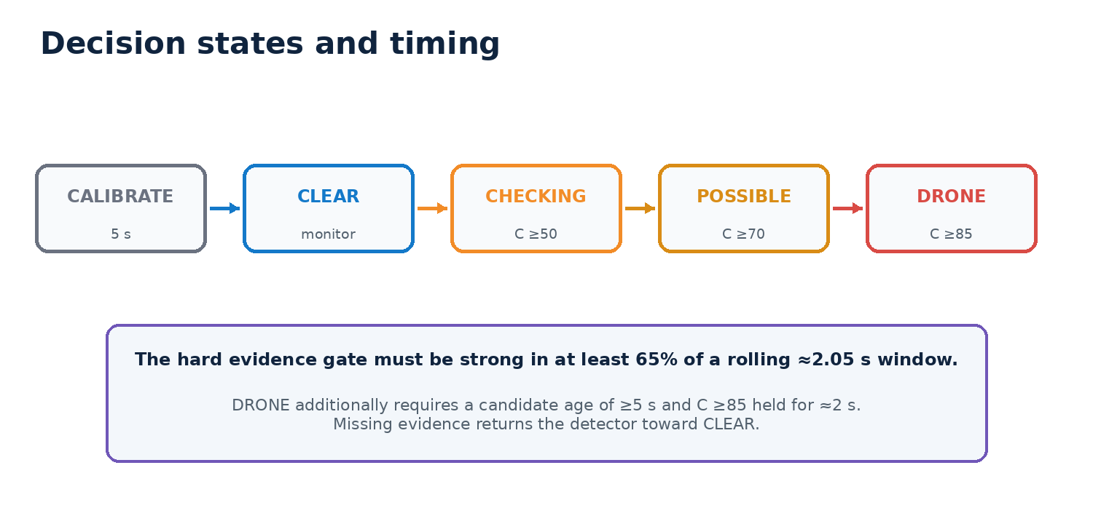
Figure 4. Confidence thresholds and elapsed-time rules control the displayed state and motor.
The rolling history contains 64 analysis windows, approximately 2.05 seconds. It becomes trustworthy after 32 windows. dutyEvidenceOk becomes true only when at least 65% of the filled history contains strong windows.
Transition | Required conditions
CLEAR → CHECKING | Active candidate, C ≥50, candidate age ≥0.5 s
CHECKING → POSSIBLE | Rolling duty passes, C ≥70, candidate age ≥2.5 s
POSSIBLE → DRONE | Rolling duty passes, C ≥85, candidate age ≥5 s, grade held ≈2 s
Any active state → CLEAR | Qualifying evidence absent for approximately 2 s
DRONE → POSSIBLE | Duty fails or C <70 for approximately 1 s

Why the detector waits
- Claps and impacts are loud but short.
- Speech and music change spectral structure rapidly.
- A passing vehicle may create only a few matching windows.
- A rotor usually maintains related tones and repeated timing for longer.
MOTOR RULE GPIO 27 pulses the vibration motor only in the final DRONE state. CHECKING and POSSIBLE provide information but do not activate the alert.

7. Direction, OLED and Serial Plotter

Direction calculation
The code calculates normalized side bias and smooths it for about one second:
bias = (leftEnergy − rightEnergy) / (leftEnergy + rightEnergy)
Smoothed bias | OLED
Greater than +0.12 | LEFT
−0.12 to +0.12 | CENTER
Less than −0.12 | RIGHT

OLED fields
Field | Meaning
CLEAR / POSS / DRONE | Current state
C | Smoothed confidence, 0–100
E | Live combined energy
M | Adaptive minimum energy threshold
Dir | Rough side bias
T:Y / T:N | Rolling strong-evidence duty passes or fails
F: Hz | Strongest live spectral peak, informational only
USB | External power source; not a charge percentage

Serial Plotter traces at 115200 baud
Trace | How to read it
Energy / Threshold | Energy is normalized against M; threshold is shown at 100
Confidence | Final smoothed C
Harmonics / HarmonicFit | Feature points and family completeness
Spectrum / Modulation | Shape and controlled-variation evidence
Persistence / MicAgree | Time consistency and two-channel agreement
HardGate / GateDuty | Current strong window and rolling percentage
State | 0 CLEAR, 33 CHECKING, 66 POSSIBLE, 100 DRONE

8. Testing, tuning and acceptance

Test in this order
Test | Expected behavior | If it fails
Quiet five-second startup | M settles, then CLEAR | Inspect I2S noise and calibration
Tap each microphone | Distinct L/R response | Correct slot mapping or SWAP_MIC_CHANNELS
Pure tone | May show frequency; must not reach DRONE | Raise structure/modulation gates
Speech, music, Instagram video | Short activity but no final alert | Inspect HarmonicFit, GateDuty and modulation
Fan, motor, tools, traffic | Log as hard negatives | Tune gates using repeated trials
Drone WAV through speaker | Useful preliminary response | Do not treat as range validation
Real drone outdoors | Repeat tests by model, distance and direction | Use results for final threshold tuning

Field record for every run
- Drone model, propellers, maneuver and approximate rotor load.
- Distance, altitude, azimuth and orientation relative to microphones.
- Weather, wind, ground surface and competing sound sources.
- E, M, f0, HarmonicFit, feature scores, confidence, hard gate, gate duty and state.
- Whether the result is a true detection, missed detection or false alert.
TUNING RULE Change one constant family at a time. Tune on one group of recordings, then verify on separate drone and non-drone recordings. Otherwise the firmware will be optimized for familiar samples instead of real-world generalization.

Suggested MVP acceptance evidence
- A documented detection rate within a clearly stated tested range and environment.
- A documented false-alert rate across difficult non-drone sounds.
- No final DRONE state from isolated pure tones, impacts or short loud media clips.
- Repeatable left/center/right behavior after physical channel verification.
- Alert latency and release behavior consistent with the state-machine specification.

9. Code map and research basis
Code area | Responsibility
readAudioHop() | Read stereo I2S, update rolling buffers and energy
runFFT() | Calculate left and right Hann-windowed spectra
analyzeSpectrum() | Noise floor, live peak, harmonic-comb f0 and spread
updateModulation() | Track controlled frequency and amplitude movement
computeScores() | Feature points, hard gate, persistence and rolling duty
updateNormalStateMachine() | Apply confidence and timing transitions
adaptBackground() | Update M only in safe background conditions
updateDirection() | Smooth rough L/C/R energy bias
updateMotor() / updateOLED() | Provide final alert and diagnostic display
debugPrint() | Serial Plotter or human-readable diagnostics

How the device works:
Before the device confirms a drone, it checks:
- Sound level: The sound must be stronger than the normal background noise.
- Base frequency: It must find a possible motor or propeller frequency.
- Harmonics: At least 3 related frequencies must match that base frequency.
- Sound shape: The sound must be more complex than a simple phone test tone.
- Controlled variation: The frequency should move slightly like a real motor, not remain perfectly fixed or jump randomly.
- Two microphones: Both microphones must hear the sound.
- Stability: At least 65% of the tests during approximately two seconds must pass.
- Time and confidence: The pattern must continue for at least five seconds and reach at least 85% confidence.
• Sound is above background threshold M 1500
• A valid base frequency f0 is found
• At least three harmonics match

- Harmonic frequencies are repeating multiples of the detected base frequency, called f0.
For example, if the device detects f0 = 200 Hz, it checks near:
- 2× = 400 Hz
- 3× = 600 Hz
- 4× = 800 Hz
- 5× = 1,000 Hz
- 6× = 1,200 Hz
Our code allows a small tolerance around each value because real drone rotor speed constantly changes. If at least three expected harmonics are found, the sound passes the harmonic check, but the other detection criteria must still pass before the motor triggers.

• Both microphones hear the sound
• Spectrum and frequency variation look suitable
• At least 65% of the recent checks pass
• The candidate lasts at least five seconds
• Confidence reaches at least 85% and stays there for about two seconds
In simple terms: the detector checks that the sound is loud enough, has a drone-like family of frequencies, is heard by both microphones and remains consistent for several seconds before triggering.

Research translated into firmware
The implementation uses the common finding that small multirotor aircraft produce periodic shaft-rate and blade-passing tones, harmonics, and broadband propeller noise. Public datasets also show that signatures change with drone model, distance, orientation and recording system. The firmware therefore detects a persistent multi-feature pattern instead of one fixed frequency.
- UaVirBASE: synchronized multi-microphone UAV recordings across distance, altitude, azimuth and orientation. Zenodo record 15391924.
- DroneNoise Database: outdoor small-UAS overflight recordings from the University of Salford. Figshare record 22133411.
- Al-Emadi et al. (2021): Audio-Based Drone Detection and Identification Using Deep Learning, including recorded and augmented drone audio.
- Intaratep et al. (2016): Experimental Study of Quadcopter Acoustics and Performance, reporting shaft/BPF tones and harmonics into the mid-frequency range.
- FAA ASSURE Aeroacoustic Signature of Quadrotors: periodic blade-passing harmonics plus broadband components.

Engineering limitation
These studies justify the feature design, but they do not provide universal thresholds for this enclosure and these two INMP441 microphones. Final constants must come from labelled recordings captured by the actual prototype during controlled outdoor tests.

